# **Meeting: Project Update**

**Below are the meeting notes from a video call with the team:**

## **Project Team Meeting Notes**

Purpose: Project Tasks Update



**5 min: Review new tasks in project plan**

**5 min: Discuss shipping and installation time estimates:**

* Seydou projected 7-10 days shipping timeline, 3-4 hours to integrate the POS systems
* Possible need to upgrade the POS system if S&S is running an older version (3-4 days)
* Electrician is confident they can wire both locations in two business days (16 hours), but since we can’t close the restaurants for a full day we need to schedule two half-days at each location

**5 min: Discuss menu and coupon upload time estimates:**

* Still waiting on Carter for the finalized menu and coupon value mock-ups for upload (aiming for one week but could extend to two)
* Once mock-ups are received, 3-4 hours to upload

**5 min: Discuss training time estimates:**

* Pre-training meeting to introduce tablets and changes to staff before training them on the tablets (1 hour at each location)
* Seydou will train managers first (2 hours), then managers will train all the staff at each location (2 hours for each training plus one hour before and after each training for facilitator prep/debrief)
* Gilly and Alex will coordinate with Peta to schedule staff trainings at each of their locations. Each part of the training (pre-training, manager training, staff training) will take place on different days.
* The preparations and planning for the trainings should take about one week.

**15 min: Assess which tasks (or similar tasks) the team has completed before (notes copied from whiteboard):**

* Team has high level of confidence in the estimates on the Project Plan

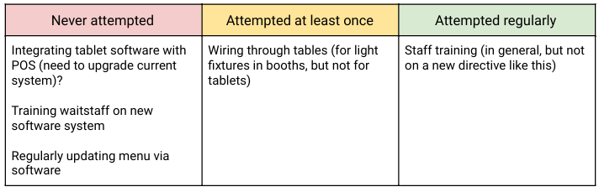

A table with three columns.

The first column, which is titled "never attempted," says: Integrating tablet software with POS (need to upgrade current system)? Training waitstaff on new software system. And, regularly updating menu via software.

The second column, which is titled "attempted at least once," says: wiring through tables (for light fixtures in booths, but not for tables).

The third column, which is titled "attempted regularly," says: staff training (in general, but now on a new directive like this).

**10min: Next steps:**

* Follow-up with Carter on menu
* Follow-up with Gilly and Alex about staff meeting scheduling
* Check on POS status
* Determine how many tablets we need to order for each location
* Book electrician for specific dates
* Set a date for staff training at each location and update staff calendars
* Start drafting a training plan